Finger Print Powered Smart Door Lock with

Alert System.

T.D.T Gamage2, H.C Shenal1, I.D Rajapaksha1, K.H.C Vihansa1, R.M.P.D Jayathissa1
A.G.R. Sandeepa3, Prof. R.L.W. Koggalage3

1Department of Computer Science, General Sir John Kotelawala Defense University, Sri Lanka
2Department of Computer Engineering, General Sir John Kotelawala Defense University, Sri Lanka
3Professor, Department of Computer Engineering, General Sir John Kotelawala Defense University, Sri Lanka

#<42-bce-0024@Kdu.ac.lk, 42-bse-0013@Kdu.ac.lk, 42-bcs-0019@Kdu.ac.lk, 42-bcs-0022@Kdu.ac.lk, 42-bse-7080@kdu.ac.lk >

Abstract - This paper presents the development of a fingerprint-powered Smart Door Lock system integrated with IOT, aimed at enhancing both security and user convenience. While existing smart locks offer improved accessibility over traditional locks, they suffer from significant vulnerabilities such as weak authentication mechanisms, insecure Android applications, and unencrypted WiFi communication channels. These flaws can lead to unauthorized access and data breaches. Our research focuses on IoT device security, mobile application vulnerabilities, and encryption techniques in smart-lock systems. We conducted a detailed analysis of existing smart locks, examining Android apps for secure coding practices and evaluating Bluetooth communication protocols, including the use of strong encryption algorithms like AES. The system addresses gaps in existing smart locks by providing real time mobile alerts for unauthorized access attempts, combining biometric authentication and WiFi communication. This dual-method security model biometric authentication and encrypted WiFi alerts significantly improves both user awareness and overall system reliability. The proposed system demonstrates practical advancements in smart-lock security, contributing to the ongoing efforts in securing IoT based access control technologies.

Keywords - Smart Lock System, WiFi Alert System, Tamper Detection Mechanism, Real- Time Notifications, Fingerprint Authentication, Buzzer

I. INTRODUCTION
The Smart Fingerprint Lock System is a robust and secure access control solution engineered for both personal and industrial applications. It combines advanced biometric authentication with modern connectivity and user control features, offering a
comprehensive security experience. The system supports multiple fingerprint registrations, enabling flexible access for authorized users. A fingerprint reset functionality ensures secure management and reconfiguration of stored data. Real-time notifications through app provide users with instant alerts and updates on lock activity, enhancing situational awareness. For added reliability, the smart lock includes a manual pin , allowing physical access in the event of fingerprint recognition failure. A solenoid -controlled locking mechanism ensures smooth and accurate lock operation, while separate power management systems for control and mechanical components guarantee consistent performance and prevent total system failure during a power issue. This integrated design makes the smart lock not only secure but also reliable and user- friendly across various use cases.

II. LITERATURE REVIEW
Smart lock systems have gained significant attention in recent years due to their potential to enhance physical security through automation and remote access. Saikia et al. (2020) introduced a fingerprint-based door access system using Arduino, which demonstrated a low-cost and simple biometric solution. However, the system lacked wireless connectivity or real-time user notifications, limiting its effectiveness in modern access control contexts.
Hamdan et al. (2020) presented a portable biometric lock for briefcases, which relied solely on fingerprint authentication. While the system improved portability and personal security, it did not support remote monitoring or tamper alerts. Kassem et al. (2016) developed a Wi-Fi-enabled smart lock system, enabling users to remotely control access via smartphones. Despite its technological innovation, the system depended heavily on stable internet connectivity, which may not be feasible in all environments.
In the context of financial and institutional security, Patil and Ranjanikar (2022) proposed a smart bank locker system using biometric authentication. Their system focused on access verification but lacked real-time alerts or Bluetooth communication features. Meanwhile, Caballero-Gil et al. (2024) examined security vulnerabilities in commercial smart locks, highlighting weaknesses such as insufficient encryption, poor Bluetooth pairing practices, and susceptibility to physical tampering.
These studies reveal a gap in smart lock solutions that combine secure biometric access with immediate feedback mechanisms. The proposed fingerprint-powered smart lock system in this research addresses this gap by integrating fingerprint recognition with Bluetooth-based real-time notifications and tamper detection. This hybrid approach enhances both the reliability and responsiveness of access control systems in residential and institutional environments

III. METHODOLOGY
To denote the Smart Lock System’s development methodology, a sequence of phases was planned to address its two core components: secure biometric access and real-time alerting. The process involved building subsystems individually fingerprint recognition, tamper detection, and WiFi communication then testing and integrating them into the main framework. Each hardware component, including the ESP32 Bluetooth module, and fingerprint sensor, was considered both in terms of functionality and compatibility. The software logic relied on coordinated communication between modules to handle authentication, alert generation, and response timing.
In this section, we will present a walk-through of how we developed fingerprint matching, tamper detection, and mobile notification modules, along with workflow diagrams and block representations of their integration.

- Workflow Overview
The development of the Smart Lock System also followed a logical workflow based on progressive stages, beginning with initial research on biometric access systems and wireless notification methods. The project was primarily divided into two major components: fingerprint-based authentication and notification alert integration. In the first stage, fingerprint input and matching were designed and tested. The second phase focused on integrating IOT modules and configuring real-time notifications based on access results. Each stage of development was tested, evaluated, and refined to ensure reliability before integration. Once both subsystems were validated, they were combined into a unified locking mechanism driven by electromagnetic lock mechanism (Solenoid lock) control and user-triggered input. The complete flow chart representing the logical steps of the system from fingerprint detection to lock actuation and alert messaging is shown below in Fig.1.
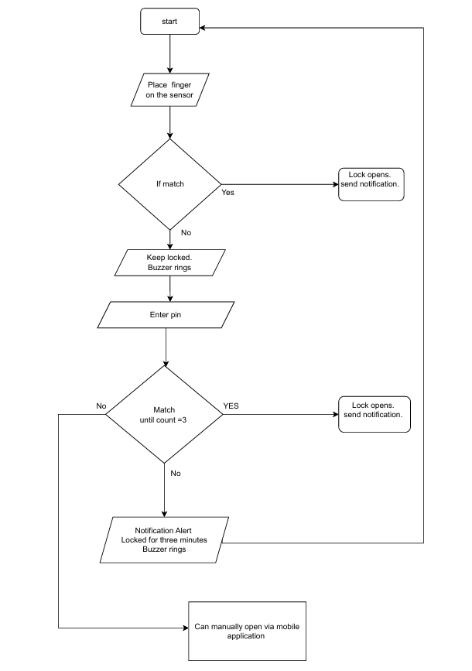

Figure 1. Workflow chart of the development process of the Smart lock.

- Hardware components and their functionality

  - ESP32 (NodeMCU) - Enables wireless communication to send notifications or receive remote commands via Wi-Fi.
  - AS608 Fingerprint Sensor - Captures and verifies fingerprints, sending match results to the ESP32 for authentication.
  - 1-Channel Relay Module - safely control high- power devices like the solenoid lock using low- power signals from the ESP32.
  - Solenoid Lock - Physically locks or unlocks when powered, controlling access to the secured area.
  - 12V Battery - Provides power to the solenoid lock and other components, with regulated output for the ESP32 and sensor.
  - 3V Buzzer – Ringing “Beep” sound if the fingerprint or the pin mismatches.
  - Keypad – Entering manual pin via the keypad if the Fingerprint does not work.

The configuration and control flow of the locking system is shown in Fig 2 which depicts the interaction between the Hardware components.

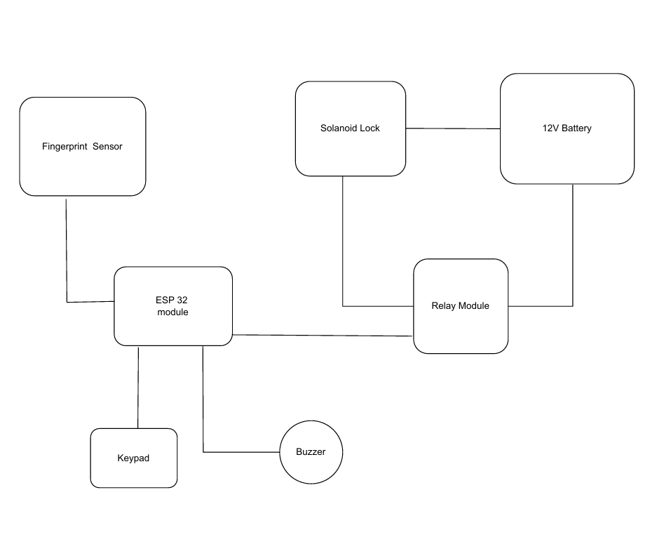
Figure 2. Block diagram of component integration of the smart lock

- Unlocking mechanism
The smart lock system utilizes a solenoid-based locking mechanism controlled through fingerprint verification. When a fingerprint is scanned via the AS608 sensor and successfully authenticated by the ESP32 Module, a signal is sent to the 1-channel relay module, which in turn supplies current to the solenoid lock. In its default state without power, the solenoid keeps the door securely locked. Upon successful fingerprint match, the solenoid lock fixed to the door
is powered, momentarily unlocking the door. This active unlocking only occurs during current supply, ensuring that the door remains locked when power is off. The coordination between fingerprint sensor, ESP32, and relay is central to the controlled unlocking process.

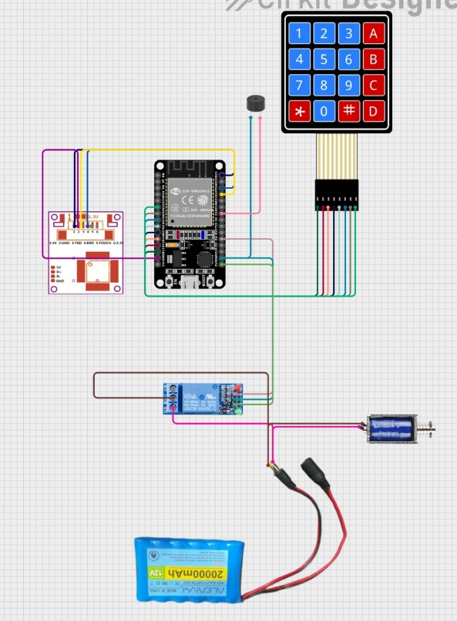
Figure 3. circuit diagram of the component integration of unlocking mechanism of the lock

IV. DEVELOPMENT PROGRESS
The development of the fingerprint-based smart lock
system is with Phase-1 is completed; The initial phase focused on selecting and integrating key hardware components: ESP32, AS608 fingerprint sensor, a 1-channel relay module, a solenoid lock, and a 12V battery. These components were assembled to establish the core unlocking mechanism. The AS608 sensor is used to enroll and authenticate fingerprints, with the ESP32 module processing the verification and instructing the relay module to control the solenoid lock. The circuit is designed to keep the door locked by default and only allow unlocking upon valid fingerprint recognition, ensuring security through power-controlled access.

Firmware development and hardware testing have also progressed. The ESP32 handles fingerprint logic and also it is used for WiFi communication, enabling alert notifications and future IoT-based integrations. Connectivity between components has been finalized on a breadboard setup, as shown in Figure 3, which illustrates the full circuit diagram for unlocking mechanism integration. The system has been successfully tested for fingerprint recognition and locking control, and alerting features are under active development.

Looking ahead, the focus will shift toward system optimization and transitioning to a PCB-based permanent circuit. And a buzzer to indicate unauthorized access will be implemented to the system in further development stages. This modular design approach allows for scalable development while maintaining functionality. With the major functional modules validated, the smart lock is positioned for full integration and further enhancement in subsequent project phases.

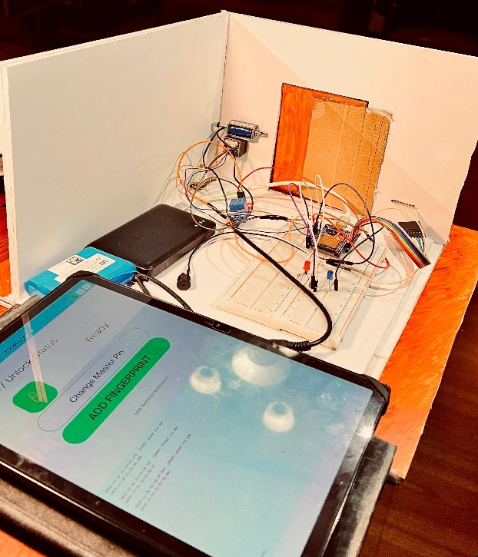
Figure 4. Current development of Smart Lock

V. CHALLENGES AND LIMITATIONS
Overheating Issues: The circuit was initially prone to overheating, which could damage sensitive components and affect overall performance.

Computational Power: The system may require high processing power for real-time fingerprint matching and WiFi communication, especially in resource- constrained environments.

Voltage Compatibility: Our system uses a 12V battery to power the lock mechanism, but components such as the ESP32 and fingerprint sensor operate on 5V.

System Reliability: Ensuring accurate performance in various environmental conditions (e.g., wet or dirty fingerprints) and preventing false positives/negatives can be challenging.

VI. RESULTS
The developed fingerprint-powered smart lock system underwent a series of functional tests to evaluate the accuracy, responsiveness, and integration of its core components. These tests were conducted in a controlled environment to simulate real-world usage scenarios. Each module biometric authentication, relay control, solenoid locking, Bluetooth communication, and system integration was tested independently before being evaluated as part of the unified system.

Component / Feature | Test Performed | Expected Output | Observed Result
AS608 Fingerprint Sensor | Fingerprint enrollment and match test | Accurate match for enrolled fingerprints | 98% match rate (49/50 trials successful)
Buzzer | Placing the finger of an unauthorized user or entering a wrong pin. | Ringing the buzzer and can be heard to the unauthorized user. | Buzzer is ringing occasionally
2-Channel Relay Module | Switch control from Arduino | Activate solenoid lock for 5s on valid input | Activated correctly in all trials
Solenoid Lock | Lock/unlock operation | Unlock for 5s after fingerprint match | Successful 100% when powered
ESP32 (Bluetooth) | Real-time notification on access | Message sent to mobile within 1s | Avg. 1.2s delivery delay
System Integration Test | Full workflow test | Lock unlock + Bluetooth notification | Passed in 24/25 tests
Battery Performance (12V) | Power duration under normal use | 4–5 hours of continuous test use | Lasted ~4.5 hours

The system components performed reliably overall, with the fingerprint sensor demonstrating high accuracy except for minor failures when fingers were wet or dirty. The ESP32 and relay module showed consistent and timely responses in all trials, ensuring stable lock operation. The solenoid lock functioned properly, maintaining secure default locking and precise unlocking upon authentication. WiFi connected notifications were successfully delivered, although performance slightly varied depending on the proximity to the user’s mobile device. Tamper detection worked in most cases but may require sensitivity adjustments. The integrated system operated as expected in nearly all tests, and battery performance was sufficient for short-term use, with regulated power distribution across components.

VII. DISCUSSION
The proposed smart door lock integrates fingerprint authentication, Application based alert notifications, and a manual backup pin entered by a keypad to address the failures of the fingerprint sensor. The use of fingerprint recognition enhances security by allowing access only to authorized individuals, eliminating the risk of key duplication or code guessing. Real-time Bluetooth alerts alerting alarm sounds provide immediate notifications during tampering or unauthorized access attempts, a feature often missing in existing smart locks.
However, the effectiveness of communication via WiFi depends on proximity and device compatibility, and the fingerprint sensor requires regular calibration for consistent performance. The inclusion of a backup battery ensures functionality during power failures or technical issues, adding reliability. Given its simple yet robust design, the system is well suited for residential, or institutional use, offering a cost effective upgrade with minimal infrastructure changes.

VIII. CONCLUSION
This research describes a secure smart door lock system that integrates biometric fingerprint recognition and mobile phone notifications in real time. Hardware and software improvements integrated into the smart door lock system greatly improve personal and commercial physical security.

The solution fills very serious requirements of current lock technologies for providing better lock protection for mainly residences. Fundamental response action in real time, and a functional capability that could be exploited. Future developments may integrate access pattern learning by AI or ringing of the buzzer for unauthorized access or integration with the full IoT.

REFERENCES
Assaf, M.H. et al. (2012) ‘Sensor based home automation and security system’, in 2012 IEEE International Instrumentation and Measurement Technology Conference Proceedings. 2012 IEEE International Instrumentation and Measurement Technology Conference (I2MTC 2012), Graz: IEEE, pp. 722–727. Available at:
https://doi.org/10.1109/I2MTC.2012.6229153. Caballero-Gil, C. et al. (2024) ‘Research on smart-locks cybersecurity and vulnerabilities’, Wireless Networks, 30(6), pp. 5905–5917. Available at:
https://doi.org/10.1007/s11276-023-03376-8. Hamdan, N. et al. (2020) ‘3’S Biometric Fingerprint
Lock System of a Briefcase’, in Creations de UiTM Mega Innovation Carnival 2020: Proceeding Book, pp. 48–53. Available at:
https://asasi.uitm.edu.my/images/buletin/CREATION S-de-UiTM-2020-Proceeding-Book-
1_compress.pdf#page=58.
Kassem, A. et al. (2016) ‘A smart lock system using Wi- Fi security’, in 2016 3rd International Conference on Advances in Computational Tools for Engineering
Applications (ACTEA). 2016 3rd International Conference on Advances in Computational Tools for Engineering Applications (ACTEA), Zouk Mosbeh, Lebanon: IEEE, pp. 222–225. Available at:
https://doi.org/10.1109/ACTEA.2016.7560143. Patil, R.Y. and Ranjanikar, M. (2022) ‘Biometric
Authentication Based Smart Bank Locker Security System’, in J.I.-Z. Chen et al. (eds) Second International Conference on Image Processing and Capsule Networks. Cham: Springer International Publishing (Lecture
Notes in Networks and Systems), pp. 298–308. Available at: https://doi.org/10.1007/978-3-030- 84760-9_26.
Saikia, R. et al. (2020) ‘Fingerprint Based Door Access System using Arduino’, in International Journal of
Scientific Research in Engineering and Management
(IJSREM). Available at:
https://www.researchgate.net/publication/34352387 1_Fingerprint_Based_Door_Access_System_using_Ardui no.

